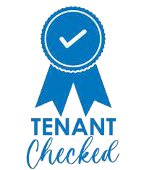



Tenant Voice Strategy
2026 - 2029
Your Voice Matters

www.archeshousing.org.uk

How you can shape our homes
and services:

At Arches Housing, we believe our tenants are the ones best equipped to tell us what works well – and what needs to improve.

This Tenant Voice Strategy explains:

- How we listen to tenants
- How your feedback shapes our decisions
- How we meet our legal and regulatory responsibilities
- How you can get involved, if you choose to.

You do not need to attend meetings or be part of a group to share your views. Every piece of feedback matters.

Our promise to you:

We will:

- Listen carefully to what you tell us
- Make it easy for you to share your views
- Be honest about what we can and cannot change
- Show you what we have done as a result of your feedback
- Keep improving how we involve our tenants.

Your voice helps us deliver quality services and quality homes – for every tenant, every time.

Page 2

Your voice and your rights:
Listening to tenants is not only important to us – it is a key requirement for all housing providers.

As a social landlord, we must:

  - Be transparent and accountable
  - Offer meaningful opportunities for tenants to influence decisions
  - Ask for feedback and publish how we are performing
  - Involve tenants in matters relating to the safety of their homes

This Tenant Voice Strategy explains how we will meet these responsibilities in a clear and meaningful way.

Tenant Checked:

Tenant checked means that this strategy has been developed and reviewed in consultation with tenants.
This means that it aligns with tenants needs, preferences and feedback.

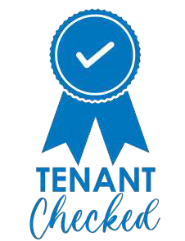

Page 3

How we listen - our three principles:

Everyone should be able to have their say
1
We want all tenants to have the opportunity to be heard, whatever their background, circumstances or level of confidence.
What this means for you:

- There are lots of ways to share feedback – surveys, conversations, events and groups
- You can choose how involved you want to be
- We check who we are hearing from and take action if some voices are missing
- We work with local partners to reach people who may find it harder to get involved
- We can offer information, training and support if you want to be more involved.

Your feedback should make a real difference
2
Listening only matters if it leads to change.

What this means for you:
  - We involve tenants early, not after decisions are already made
  - We use feedback from everyday services including repairs, lettings and complaints
  - We share tenant insight with senior leaders and Board members

- We welcome challenge and scrutiny
- We use your experiences to shape how services are delivered.

You should be able to see where your feedback has influenced decisions.

We will be open and honest
3
Good relationships are built on trust.
What this means for you:

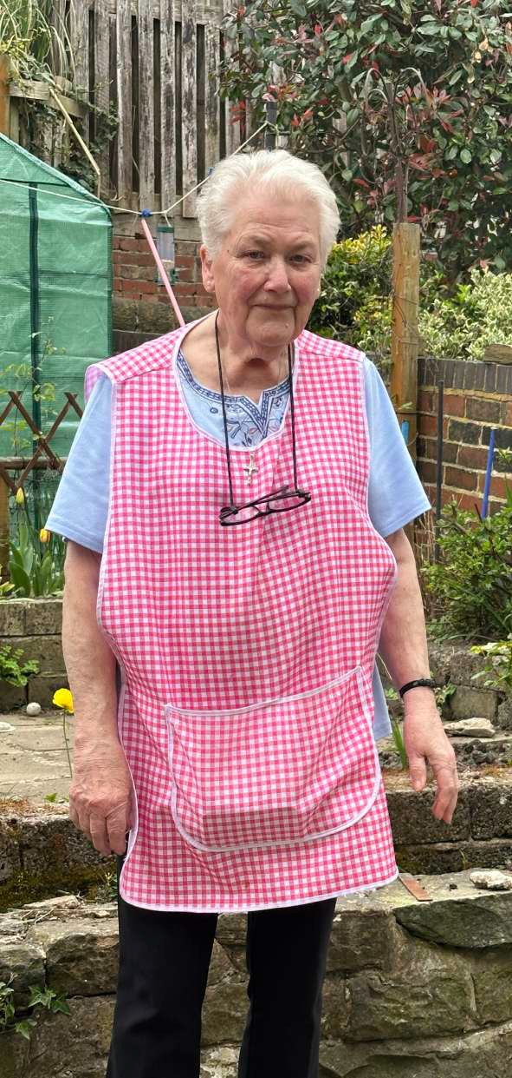

Page 4
- We tell you what we have heard
- We explain what we are doing as a result
– and why
- We use a clear “You Said, We Did” approach
  - You will have opportunities to speak directly to senior leaders and Board members
  - Listening to tenants is everyone’s responsibility at Arches Housing.

How you can share your views:
You can tell us what you think in many ways, including:

    - Compliments, complaints and service requests
    - Short surveys after services such as repairs
    - Online, phone or face to face surveys
    - Home visits and neighbourhood events
    - Focus groups and themed discussions
    - Estate walkabouts
    - Tenant scrutiny projects
    - Neighbourhood Network

You can choose to be as involved as much, or as little, as you choose.
Getting more involved:
For tenants who want to play a bigger role, opportunities include:

    - Reviewing policies, letters and processes before they are finalised
    - Helping us improve our website and communications
    - Taking part in scrutiny projects
    - Attending “Meet the Board” events
    - Being supported to move into governance roles We will provide training, information and support you need.
How your voice reaches the top:
    - Tenant feedback is shared with senior leaders and the Board
    - Tenants speak directly to the Board following scrutiny activity
    - Tenant voice is a standing part of Board discussions
    - Board reports must show how tenant views have been considered This helps ensure decisions are grounded in real tenant experience.
Page 5

What will happen - and when?

We want tenants to clearly understand how this strategy will be delivered.

YEAR 1

Building strong foundations

In the first year, we will focus on listening well and meeting our responsibilities.
We will:

- Check that all listening activities are fair and accessible
- Report on who we are hearing from and where voices are missing
- Take action to engage under represented tenants
- Hold our first “Meet the Board” event
- Provide training and support for Neighbourhood Network members
- Set up a central system so feedback is recorded and used
- Hold our first Tenant conference, explaining how tenants can influence services.

YEAR 2 Reaching more voices
In the second year, we will strengthen influence and accountability.
We will:

  - Deliver a targeted plan to hear from tenants we hear from less often
  - Set up a new tenant group to review policies, processes, letters and digital services
- Support and mentor tenants who want to be more involved
- Hold two “Meet the Board” events
- Run open information and training sessions for tenants.

YEAR 3 Checking and improving
In the third year, we will review how well our approach is working.
We will:

  - Carry out an independent review of tenant involvement
  - Make sure tenant feedback is built into all key policies and strategies
- Use what we learn to improve how we listen to and involve tenants in the future.

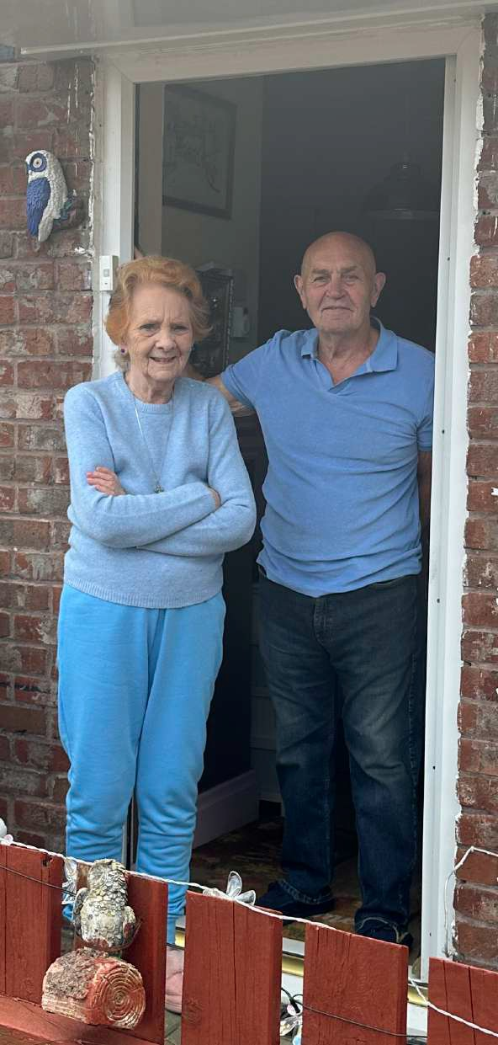
Page 6

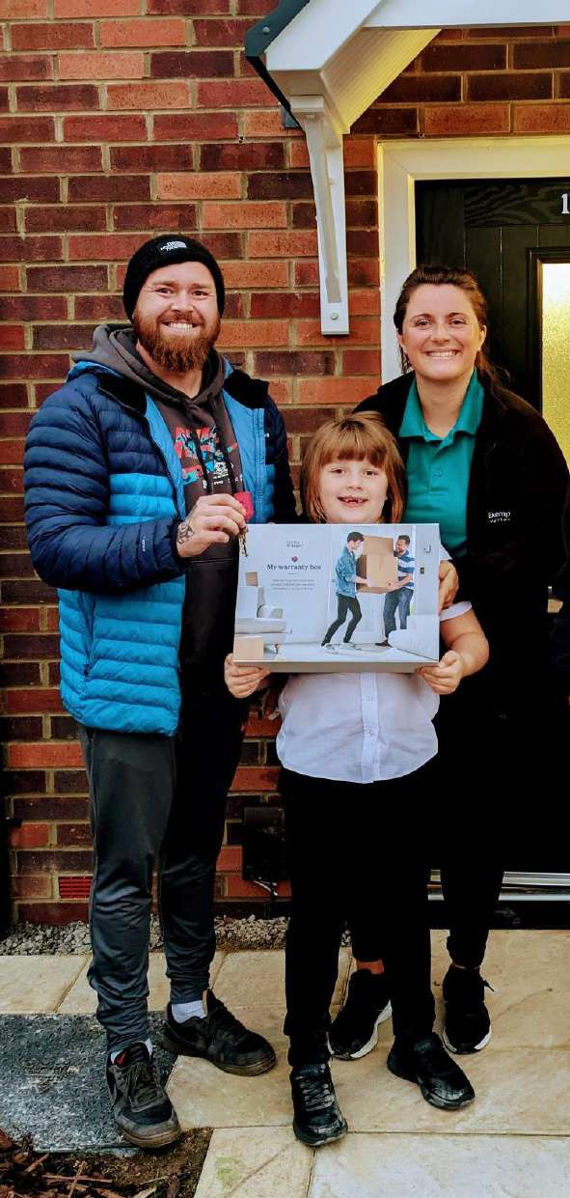How will we know if we are
doing well?

We track our progress by looking at:

  - Tenant satisfaction with our services
  - Whether tenants feel listened to
  - How many tenants are involved
  - Whether we are hearing from a wide range of people
  - How many improvements come directly from tenant feedback

We will share this information so you can see how we are performing and hold us to account.

In summary:
This strategy is about more than listening – it is about influence.

Whether you complete a survey, speak to a colleague, or get involved more closely, your voice helps shape:

  - Our services
  - Our decisions
  - Our homes
  - Our future

By listening, learning and acting on what you tell us, we will continue delivering quality services and quality homes – for all tenants, every time.

Page 7

Engagement Model

Board

Neighbourhood Network

Targeted Tenant Surveys

Tenant Satisfaction Measures

Delivering quality services and quality homes - for every tenant, every time.

Scrutiny

Focus Groups

Complaints and Feedback
Customer Outcome Monitoring




Page 8



Glossary of Terms...

Tenants:
People who live in our properties and whose name is on the tenancy agreement.

Social Landlord:
An organisation that provides affordable homes.

Strategy:
A plan that outlines where we want to be and how we will get there.

Board members/Board:
A group of people who oversee how Arches is run, make key decision, and ensure it delivers good services to tenants.

Tenant Scrutiny projects:
A specific group of tenants who review one particular service area or policy in detail.
Tenant Checked:
The strategy or policy has been put together with the advice and influence of Arches tenants.

Legal and regulatory responsibilities:
Making sure we follow the law and the official rules set by the Government and the Regulator of Social Housing in how we operate and deliver our services.

Regulator of Social Housing:
The independent body in England that sets standards for social landlords and makes sure customers’ homes are safe, well- managed and of good quality.

Neighbourhood Network:
A group of Arches tenants who meet regularly and hold Arches to account for how they hear the tenant voice in their services and decisions.

Page 9



Page 10



Page 11



Telephone: 0114 228 8100

Address: Arches Housing Limited
122 Burngreave Road Burngreave
Sheffield S3 9DE

 /archeshousing
/archeshousing

www.archeshousing.org.uk

