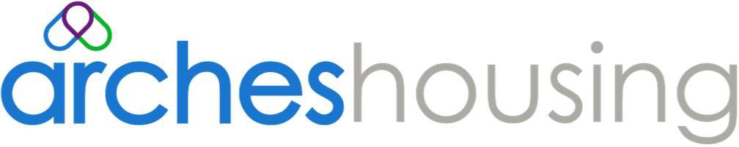

Chargeable Repairs Policy

Reference | AM02 | Version
Staff affected | All staff | Issue date | April 2019
Approved by | Board 25th April 2022 | Review Date | March 2025
Lead Officer | John Hudson | Actual Review  Date | 28.3.2025
 |  | Next Review | March 2028

- Introduction

  - This Policy sets out our approach to charging residents for repairs and related costs they’re responsible for. It describes:
    - When we’ll charge for repairs
    - How we’ll charge for repairs
    - What happens if residents don’t pay recharges
    - What residents can do if they’re not happy with a charge.

  - This Policy applies to all areas of Arches, except shared owners and leaseholders. When we use ‘you’ and ‘your’, we mean residents. The terms ‘we’, ‘our’, and ‘us’ means Arches.

  - We will not tolerate malicious or intentional damage to property and promote a responsible attitude by our residents. You’re responsible for any accidental or deliberate damage caused by members of your household or any visitors (including children).

  - We will ensure you’re aware of your responsibilities when you sign your occupancy agreement. We encourage you to have contents insurance to cover accidental damage to the property.

  - The policy will be published on our website.

When we will charge for repair

  - We will charge for repairs when they are:

    - Your responsibility (as detailed in your occupancy agreement and our Responsive Repairs Policy)
    - The result of damage caused by you, other household members or a visitor (whether deliberate, accidental or through negligence).
    - Required to rectify work or repairs you’ve carried which aren’t to the required standard.
Appendix One details examples of when we’d charge. If the work is our responsibility, we’ll follow our Responsive Repairs Policy.
  - We may not charge you in exceptional circumstances, including:

    - Where damage is criminal, caused either by an unknown person or in situations of domestic abuse, or harassment
    - Where damage is found following the end of a tenancy and it is considered insensitive or inappropriate to pursue the former resident or their next of kin for the charges. For example, where residents have been moved into hospital, residential care, or they’ve died.

How we will charge for repairs

  - When you report a repair to us, we’ll let you know who’s responsible wherever possible – you or us (in line with your tenancy agreement). If it’s us we’ll follow the Responsive Repairs Policy to get the work done.
  - If it’s your responsibility but an emergency, or a health and safety risk or your tenancy has ended, we’ll carry out the works and recharge the costs to you. We will arrange a payment plan if you are not able to pay in full for these works.
  - If it’s something you’re responsible for (see Appendix One) and not an emergency, you’ll need to complete the work yourself. You may carry out the work yourself or pay a suitably qualified person. These are subject to quality checks and we may charge you if the work carried out is not to the required standard and we incur a cost to rectify this.
  - You can ask us to carry out the work on your behalf, if you have a clear rent account or can evidence a pattern of making regular payments to us we will do this subject to you agreeing a repayment plan that is acceptable to us.
    - If you ask us to do the work, we will:

      - Tell you the cost
      - Agree a payment plan if you tell us you need to spread the cost
  - We will not allow you to spread the cost of works you would like us to undertake that are not our responsibility or where you have a history of not adhering to repayment plans agreed with us. Under these circumstances you will need to pay the full costs of the work in advance.

What if I don’t pay for a recharge?

  - 4.1 If you don’t pay the recharge, we will:

- Look to recover the debt in line with our Income Collection Policy.
- Take court action.
- Not agree a transfer while you owe us money for a repair (except urgent moves).
- Not undertake any further works that are not our responsibility without full payment in advance.

What can I do if I am not happy?

  - If you feel you should be exempt from a chargeable repair, you can ask us to review your case. We will review the reasons for the chargeable works. We will not consider altering the amount we are charging you for works, only the reasons why.
  - If you are not happy with the amount we will charge to carry out non-emergency works you are responsible for, you will need to make your own arrangements to get the work completed. You can find another service provider and pay them to complete the work. You need to ask our permission before carrying out any alterations to your home (in accordance with your occupancy agreement). If you don’t we may charge you to rectify any alterations, you make.

Review

  - This policy will be reviewed triennially or earlier to address legislative, regulatory, best practice or operational issues.

Appendix One

We will charge for works needed that are your responsibility or there is deliberate damage. This includes but is not limited to:
- Repairs that you are responsible for: for example replacing locks and lost keys not arising as a result of a criminal act that you have reported to the Police, bath plugs
- Repairs due to damage or misuse: when works are due to damage by you, your family or friends to fixtures and fittings in your home. The damage can be accidental or deliberate. For example holes in plaster work caused by over extending a door, kitchen units caused by storing too much or worktops due to water spillage.
- Repairs that are required as a result of enforcement of a warrant executed by the police.
- Vandalism: works to rectify vandalism damage where an individual admits causing the damage or is prosecuted by the Courts.
- Alterations: works needed where you have not asked our permission to undertake alterations and we need to put things right.
- Garden and property clearance when a tenancy ended: works arising with gardens and communal areas not kept clean and tidy. Properties should be left empty, including the loft space. We will charge for the costs of removing and storing anything left in the property or garden as per your occupancy agreement conditions.
- Clearing, cleaning and repairing a dirty or verminous property: terms are defined under the Public Health Act 1936 (Section 83 as amended by section 35 of the Public Health act 1961).
- Pest or infestations that require treatment or repair works that are caused by the
customer but are required due to risks of health and safety.

