Drone Operations Policy and Procedures for Property Inspection

Reference | 01 | Version | 1
Applies to | All staff, contractors, third party operators and residents of Arches Housing including owners of neighboring properties | Issue date | July 2026
Approved by | Will Doole  (Assistant Director of Finance and Corporate Services)  Kat Allott-Stevens (Director of Operations)  John Hidson  (Chief Executive) | Review Date | Jan 2027
Lead Officer | Scott Smith  (Head of Repairs, Maintenance & Building Safety) | Reviewed By

1. Statement of intent
This policy establishes the framework for the safe, legal, and ethical operation of drones (Unmanned Aircraft Systems – UAS) for property inspection across Arches Housing Ltd’s housing stock. It ensures compliance with Civil Aviation Authority (CAA) regulations and data protection laws, safeguards residents along with respecting the resident’s privacy. This policy and its procedures protects the organization’s assets and reputation.

2. Scope
This policy applies to all drone flights conducted for property inspection, asset management, or surveying purposes; all staff, contractors, or third-party operators engaged by Arches Housing Ltd; and all sites owned or managed by the organisation.

3. Legal and Regulatory Compliance
All drone operations must comply with:
- Civil Aviation Authority (CAA) regulations and the Air Navigation Order (ANO)
- UK Drone and Model Aircraft Code
- Data Protection Act 2018 and UK GDPR
- Health and Safety at Work etc. Act 1974
- Local authority by-laws and airspace restrictions
Operators must hold the appropriate CAA certification (A2 CofC or GVC) and maintain valid operational authorisation and insurance.
Insurance Compliance Addendum (Coverdrone policy alignment – Feb 2026)
- UAS Operating Mass: Arches Housing will only operate UAS with an operating mass below 40 kg (without fuel but including any airborne equipment).
- Prototype Drones: Arches Housing will not operate prototype or non–commercially released drones under this insurance.
- Notification to Insurers: Arches Housing will notify the insurer via Coverdrone of any material changes in risk (including purpose of use, geographical area, operator details, storage location, ownership, or aviation authority permissions) prior to the change taking effect.
- Evidence of Insurance: A copy of the current insurance schedule/certificate will accompany the UAS on all operations and be available for inspection.
- Cargo/Carriage: Arches Housing does not carry cargo. Items excluded by the policy (e.g., money, perishables, valuables, fine art, livestock) will not be carried.
- Sanctions & Embargo: Operations will only be undertaken in jurisdictions permitted by the policy’s Sanctions & Embargo clause (UK-only operations unless otherwise agreed in writing).

4. Responsibilities
Drone Pilot – Conduct flights safely and complete pre-/post-flight documentation and be fit to fly.
Head of Repairs, Maintenance & Building Safety (Scott Smith) in the first instance (Other Head of Departments in the second instance)) – Approve risk assessments and ensure permissions obtained.
Data Protection Officer – Oversee compliance with privacy and data laws.
Asset Repairs Team – Use imagery responsibly and store securely on SharePoint.
All activities conducted by the Remote Pilot and flying of drones must be conducted in line with this policy and procedure along with the Arches Drone Operators Manual.

5. Authorisation Process
- Submit Drone Operation Request Form (Appendix A)
- Complete Pre-Site Survey Checklist (Appendix B)
- Complete Embarkation/Arrival Checklist (Appendix C)
- Complete the on-site survey checklist (Appendix D)
- Complete Risk Assessment (Appendix E)
- Complete Pre-flight Checklist (Appendix F)
- Data Protection Impact Assessment (Appendix Q)
- Obtain approval from Head of Repairs, Maintenance & Building Safety in the 1st instance or any Head of Service in the 2nd instance.
- Notify all neighboring properties of proposed drone flight
- Obtain permissions from property managers and relevant authorities (if applicable)
- Notify schools of proposed flights or Police on 101

6. Operational Procedures
During Flight, and Post-Flight procedures must be followed, ensuring safety, compliance, residents privacy and data security.
- Complete the In-flight checklist (Appendix G)
- Complete the After Landing & Shutdown Checklist (Appendix H)

7. Risk Assessment Framework
Each flight must have a completed risk assessment (Appendix E). Hazards, risks, and control measures must be identified and approved before flight. Residual risk must be Low or Medium before proceeding.

8. Accident & Incident Reporting
All incidents, near misses, or data breaches must be reported to the Head of Repairs, Maintenance & Building Safety or any other Head of Service. Serious incidents must be reported to the CAA via the Mandatory Occurrence Reporting system.
In the event of a ‘flyaway’ this must be reported direct to DJI by submitting a DJI Care Flyaway Aircraft Report. This can be found at https://support.dji.com/
In the event of an incident occurring of which emergency action is required, follow the emergency response plan (ERP) (Appendix J)
In the event of a serious incident or accident, this must be reported to the Air Accident Investigation Board (AAIB) within 72hrs / 3 days
Where a serious accident has occurred, an Occurrence & Airprox Reporting Form must be completed (Appendix K)
An incident log must also be completed and kept up to date. (Appendix N)

9. Data Protection and Privacy
Only collect imagery necessary for inspection. Display public notices, conduct DPIAs, and store imagery securely. Personal data must be redacted or deleted promptly. All images are to be stored on SharePoint and are retained as per our data retention policy.
A Data Protection Impact Assessment must be completed (Appendix Q)

10. Training and Competency
All pilots must hold valid CAA qualifications (A2 CofC or GVC) and receive annual internal competency assessments. Training must be completed 1 month before the expiry of the expiry date. Maintenance & flight logs records must be maintained.
- Flight log template can be found on (Appendix L) however this is to be maintained by the pilot and submitted on request.
- Maintenance Log (Appendix M) must be kept with the drone at all times and completed after any maintenance has occurred.

11. Insurance
No drone flight can take place without adequate Insurance cover. This will be obtained annually and renewed before the expiry of the cover period. Flight logs, maintenance records and training must be kept up to date as per insurance requirements. A copy of this insurance must be kept with the drone at all times. (Appendix P)

12. Policy Review and Audit
This policy will be reviewed annually or after any significant change, incident, or regulatory update.

Appendix A: Drone Operation Request Form
All of the below information Must be completed before any flight can commence.
All of the below information Must be completed before any flight can commence.
Address:

Customer Name:

Date:

RPAS Pilot Name:

Pilot I.D Number:

Reason for flight:

Approving Manager

(must be Head of Repairs, Maintenance & Building Safety in the first instance and any other Head of Department in the 2nd Instance)

Appendix B: Drone Flight Risk Assessment Template

Address
ITEM |  | ACTION/CHECK |  | FINDING
PERMISSION |  | Local Authority, Land Owner
TERRAIN |  | What is the terrain (Flat/boggy/rough)
ACCESS |  | Right of way, Gates, Footpaths, Bridleways
SENSITIVITIES |  | Recreational areas, Bye Laws
OBSTRUCTIONS |  | Wires, Buildings, Masts
PEOPLE |  | Local Habitation
LIVESTOCK |  | Local Farms
ALTERNATE |  | Alternative operation / take off sites
PROXIMITIES |  | Other Aircraft (aerodromes, model sites, Heli Pads)
HAZARDS |  | Live Firing, HIRTAs, Gas Venting etc
RESTRICTIONS |  | Nuclear Power Station, Prisons
LOCAL AIR TRAFFIC |  | Do Local ATC need to be contacted?
NOTAMS/PINS |  | Any PINS/NOTAMs within the vicinity to affect the task?
WEATHER |  | 1-2 Hour Forecast, Local forecast
RISK REDUCTION |  | How can any risks be mitigated?
CONTACT | NUMBERS |  | NOTES
Nearby School / 101
Landowner
Local Hospital | 999 or 0114 243 4343 |  | Northern General

Appendix C: Embarkation/Arrival Checklist

It is important that the Remote Pilot has all the relevant information to operate the drone in a safe and efficient manner, please adjust list as required

ITEM | Embarkation | ARRIVAL | NOTES
Aircraft
Remote Controller (Charged)
Batteries (leads/chargers)
Tablet/Phone
Camera/ Filters/ Equipment/SD Cards
Laptop/Tablet
Warning Signs
Take off landing pad
Cordon / Zoning Posts / Equipment
Anemometer
First Aid Kit
Fire Extinguisher
Job Brief / Survey Paperwork
Logbooks

Appendix D: On-Site Survey Checklist

Date |  |  | Job Number
Pilot |  |  | Wind Speed
Observer |  |  | Temp ⁰C
Time started |  |  | Time finished
ITEM |  | ACTION/CHECK |  | FINDING
IM SAFE |  | Are the operating crew fit to fly
PERMISSION |  | Do we have landowners permission
OBSTRUCTIONS |  | MASTS, WIRES, BUILDINGS, TREES, RIVERS, CANALS, INDUSTRIAL
VIEW LIMITATIONS |  | Anything that may impair visual line of site (VLOS)
PEOPLE |  | Have neighbours been informed?
LIVESTOCK |  | Animals, Wildlife
TERRAIN |  | Flat, Sloped, Rough, Wet, Icy
PUBLIC |  | Public Access? Signage Required?
PROXIMITY |  | Clearance away from buildings etc.
TAKE OFF AREA |  | Where is the safest convenient position
LANDING AREA |  | Where is the safest convenient position
EMERGENCY AREA |  | Where is the safest convenient position
HOLDING AREA |  | Where is the safest convenient position
SCHOOLS OR POLICE |  | Do schools or police need to be informed?
AIR TRAFFIC |  | Do we need or have Clearance?
BRIEF/  COMMUNICATION |  | Brief & Position Crew and Clients.  Dangers/Responsibilities/Incapacitation  /Flyaway/Task
NOTES

Appendix E: DYNAMIC RISK ASSESSMENT

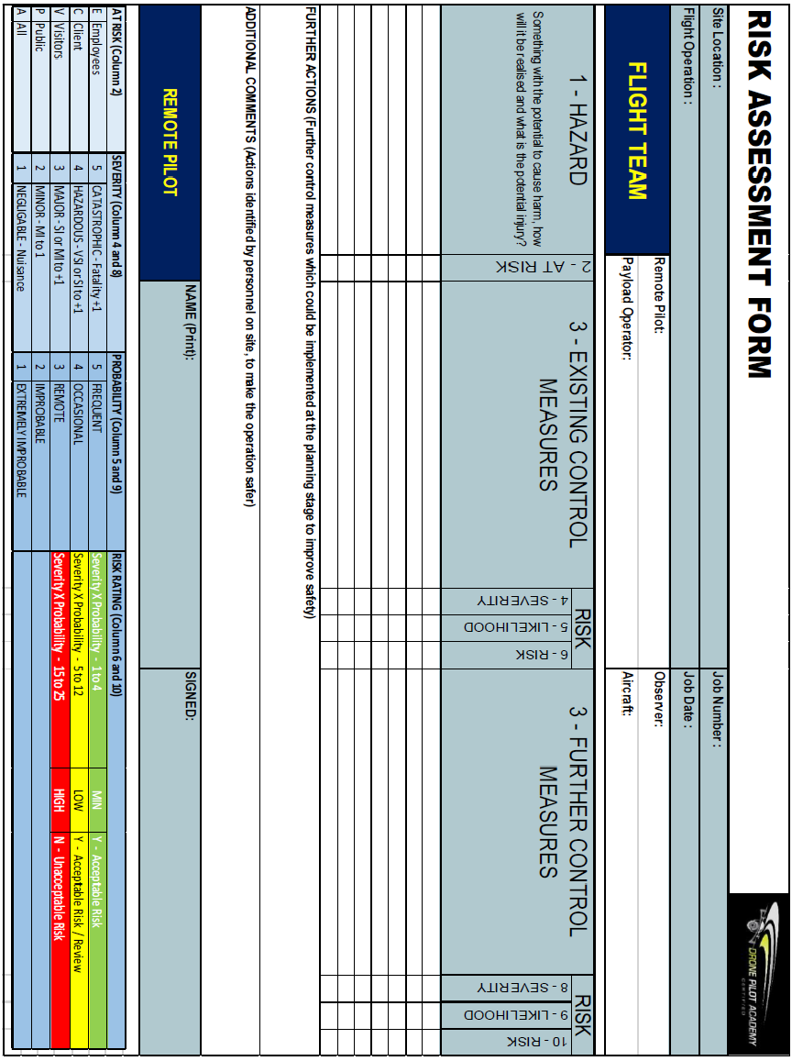

Appendix F: Pre-Flight Checklist – DJI Mini Pro 5

ITEM | ACTION/CHECK | Initials
CAMERA | Remove Gimbal Lock
AIRFRAME | Unfold arms if required. Check for damage, wear, tightness of fittings, condition and secure, secure camera, SD Card fitted.
PROPELLERS | Check for damage, fit and confirm secure
BATTERIES | Use next cycle battery.  Check Condition, battery % sufficient and fit securely into airframe.
AIRCRAFT | Call “CLEAR PROPS”  Turn On.  Check connected to drone – Steady Green on RC  Wait for Diagnostic, IMU warm up and GPS Lock to be completed.  Confirm Rear LEDs (Slow Green = 6+ GPS or Slow YLO Blink <6 GPS)  Any other colours - Shutdown and refer to User Manual.
Remote Controller | Check Battery Level and Turn on Remote Control  Connect to Drone  Check Safety Setting:  Max Altitude (120m)  Max Distance (500m)  Auto RTH Altitude (Check tallest object height +10m)  Check IMU / Compass – Calibrate if prompted  Check Battery Cell levels x 2, Voltage & Temperature (Min 15C)
TELEMETRY/VIDEO LINK | GPS (Ready to Fly) in GREEN  Check number of Satellites  Check RC Power & Signal Strength  Check Collision Sensors (If fitted)  Check HD Signal Strength  Check Battery %
CAMERA | Check SD Card memory levels – Format if required.  Set correct values for conditions.  Lens Clear / Fit ND Filter if required.  Test Operation – Tilt / Check volume sufficient
BRIEF | Brief Crew and Clients about  Task – Confirm / clarify what it is & Weather suitable  Lookout – Uninvolved Persons/Aircraft  Flyaway – Dangers to clients & What to do if comes towards  Incapacitation – What to do if Pilot unwell / RTH  Ensure all Crew, Public, Clients in safe positions
ATC | Call ATC if required (caution: you are within allocated timings)
RP DECLARATION | I am reasonably satisfied that the flight can safely be conducted
STARTING | Call “STARTING” and start the RPAS motors up
LOOKOUT 360֠/TAKE OFF | Follow Take off CL (see annex F if required). Take one Final look around, check with flight crew if all Clear then call “TAKE-OFF”

Appendix G: In-Flight Checklist – DJI Mini Pro 5

ITEM | ACTION/CHECK – After Take-Off
WEATHER | Confirm wind and precipitation are within limits
TAKE OFF | Take one final look around, check with flight crew if cordon remains secure. If yes, then call “TAKE-OFF”  Raise the RPAS slowly and safely into the air for operation.
AIRCRAFT | Conduct after take-off handling check in the Low Hover:  If Abnormal Handling Characteristics are seen – Call “ABORT” & Land Immediately.  If handling characteristics OK – Call “CONTINUING”
RTH CHECK | Instigate an RTH check if required to confirm operating normally.
ITEM | ACTION/CHECK – In-Flight
Remote Controller | Monitor for Warnings, Check Battery & Satellite Levels
AIRCRAFT | Monitor orientation and lights.  Watch for abnormal responses & vibrations.  If required conduct an ERA & relevant emergency procedure.
ITEM | ACTION/CHECK – Landing
CAMERA | Stop Recording if required.  Rotate camera to horizontal position if required.
LANDING POINT | Confirm Landing Point Clear and call “LANDING”  NB; If not clear, direct Observer to clear the area or select alternate site.
PROPELLERS | Confirm propellers have stopped moving before making an approach to the RPAS to conduct after landing / check list.
TIME | Note time of landing
BATTERY | Change if required in order to complete next flight.  Before starting check battery information & GNSS
AIRCRAFT | Check for damage, loose or missing parts, cleanliness and it is free from moisture before conducting further flight.

Appendix H: After Landing & Shutdown Checklist

ITEM | ACTION/CHECK
AIRCRAFT | Shutdown, note battery level, turn off and remove from RPAS.  Call “SAFE”. Check battery temp and store safely.
COMMUNICATIONS | Inform ATC/Controlling authority that tasking complete (if req’d)
BATTERY LOG | Record all details in Battery Log if req’d (i.e. non-intelligent batteries)
MAINTAINANCE LOG | Record flight info/faults in RPAS maintenance log.
FLIGHT LOG | Record flight time in pilots Logbook
REMOTE CONTROLLER | Turn off remote control
AIRFRAME | Check Airframe for loose nuts/bolts, wear & tear, check props.  Clean & stow in case and secure – note issues in maintenance log
REVIEW / DEBRIEF | Review Images/Video and share with office and upload to SharePoint.
INCIDENT UPDATE  & OPERATOR LOG | Any incidents to be reported to the Accountable Manager and followed up with the relevant report, including in the operator Log.

Appendix J: Emergency Response Plan (ERP)

In the event of a crash the following procedure will be followed. The procedures to be followed escalate depending on the scale of the incident.

Priorities
- Protect uninvolved people
- Protect property
- Gather evidence
- Submit an Occurrence Report (MOR/VOR)
- Conduct an Investigation
- Delivery outcome actions to prevent a repeat occurrence

IMMEDIATE ACTION:

Immediately following a crash:

- CHECK FOR DANGER
Do not enter crash site if it is not safe to do so. Do not risk injury to retrieve RPAS if it is not safe.

- ADMINISTER FIRST AID
Administer immediate first aid to anyone injured in the crash if trained or call for help if not.
- Preserving life is priority!

- CONTACT EMERGENCY SERVICES
Call 999 if the emergency services are required. Or at the very least the Police who can quickly investigate the legitimacy of the RPAS operations and confirm nothing illegal has taken place.

- RECOVER RPAS
If there has been no injury to people and no damage to property or the RPAS and it is safe to do so retrieve the RPAS.

In case of injury or damage to property or the RPAS proceed to Follow Up Actions

FOLLOW UP ACTIONS:

- HEALTH AND SAFETY
Ensure appropriate PPE is worn when recovering / dealing with RPAS that have been involved in a crash, pay particular attention to managing the RPAS battery and be mindful that LiPo batteries are highly volatile. Whilst dealing with the RPAS do not risk crew safety and broken components may have sharp edges.
- If required try and prevent anyone entering the crash site and putting themselves in danger.
- If level of danger presented escalates, move crew and bystanders further away from crash site.
- If level of danger reduces; consider if it safe to administer first aid to any casualties.
- Upon arrival of the Emergency Services control of the Crash Scene will be handed over to them.
  - Have a hand over brief ready
  - Update on ongoing activity
  - Co-operate fully with the Emergency services / Incident commander

- EVIDENCE CAPTURE
Remember all information gathered could be used as evidence in a Court of Law or as part of a formal investigation, by the AAIB, CAA or Police. (Also applies to para 3&4)
If it is safe to do so, capture photographic evidence of the crash site and consider drawing a diagram to illustrate the crash scene. Secure all your planning paperwork, as the AAIB, CAA & Police may ask to see it.
Consider capturing the following evidence:
- Panoramic photo for crash site context
- Photo of RPAS resting place
- Close up of broken components in resting place
- Photos of any vehicles / structures involved in crash
- Photo of last known flight path
- Capture time, date and coordinates of crash
- The RAMS / Planning paperwork
- Recover components of the RPAS, or the whole system to allow data recovery (see below)

- RECOVER FLIGHT DATA & WEATHER INFORMATION
- Where possible, recover flight data from the RPAS and Ground Station. This data may be sent to suitably qualified organisation for analysis / may be required for evidence by the AAIB, CAA & Police.
- It will also be good to have accurate weather information, as they will ask questions about it in the written reports. A quick snapshot from a weather app or website should detail the most pertinent information.

- STATEMENTS
Capture statements, either written or voice recordings whilst the information is still fresh in their minds. Where possible, the statement should include an account of the events leading up to the crash, the crash and activity following the crash. Have separate statements from:
- Remote Pilot
- Involved People - Flight Observer.
- Uninvolved People - Any other witnesses, e.g., general public or customer.

- INFORM ACCOUNTABLE MANAGER
If the AM is not on scene they must be informed of the crash at the earliest possible opportunity. Be ready to give details of any casualties, damage to property, the circumstances leading up to the crash, the condition of the RPAS and ongoing activity. The AM will then make a decision whether to ground any other RPAS of the same type / same components and whether to attend scene.

- INSTIGATE REPORT
Either the Remote Pilot or the Accountable Manager should inform the AAIB/CAA and a debrief should occur to confirm all actions above have been completed. A plan or delegation of tasks could also allocate jobs following on from leaving the site.
- 24-hour accident/incident reporting line: +44 (0) 1252 512299
- Debrief
- Raise follow up report within 30 days
- What support is required going forward
  - For Personnel
  - For Productivity
  - Returning to RPAS operations if appropriate

Appendix K: Occurrence and Airprox Reporting Form
The forms designed to capture the relevant information as part of gathering evidence following accident whilst conducting the ERP or following a near miss.

Occurrence form
Reference
Date |  | Time
what3words |  | Airspace class
NOTAMs |  | Airspace type
Incident type | Occurrence - Incident | Occurrence - Accident | Airprox
Causal factor | Technical failure | Human factor | Other
UA category |  | UA type
UA serial number |  | MTOM
Remote pilot
Flight crew

Wind direction |  | Wind strength
Gusts |  | Precipitation
Cloud cover |  | Visibility
Air temperature |  | Kp-Index
Details of occurrence/airprox

Witness details
Photos/video | Have photos or video be taken to aid any investigation?
General notes

Diagram of occurrence/airprox

After an occurrence the remote pilot must complete the following:

- Follow the emergency action plan in the UAS operator’s operations manual
- Report to the UAS operator as soon as possible

Incidents and accidents

- File a mandatory occurrence report within 72 hours on ECCAIRS2 https://e2.aviationreporting.eu/reporting

Report an accident or serious incident

- Air Accidents Investigation Branch
- https://www.gov.uk/government/organisations/air-accidents-investigation-branch
- Telephone - 24 hours reporting 01252 512299
- enquiries@aaib.gov.uk
- General enquiries: 01252 510300

Airprox

- File an airprox within 7 days
https://www.airproxboard.org.uk/report-an-airprox/

Appendix L: RP Flight Log

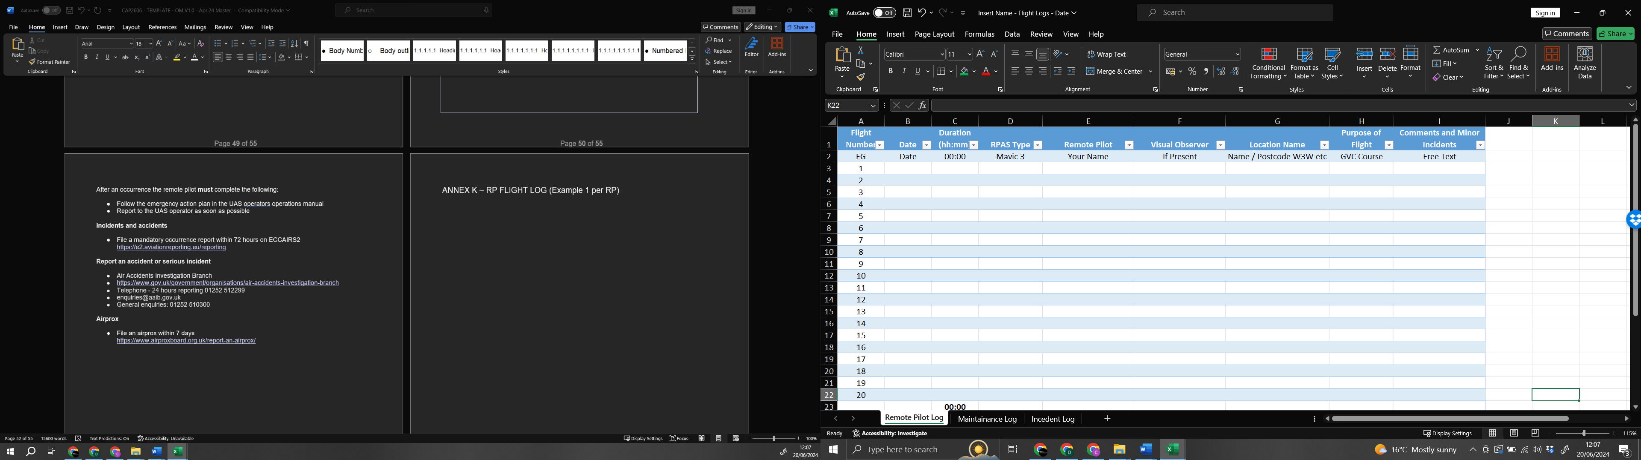

Appendix M: Maintenance Log

Aircraft: ______________________ Serial Number____________________

DATE | SERVICE / PARTS / ISSUE | NOTES / ACTION | INITIALS

Appendix N: Incident Log

DATE OF INCIDENT | TIME OF INCIDENT | INCIDENT DETAILS INCLUDING LOCATION | ANY INJURIES OR DAMAGE | ACTION TAKEN OR NOTES

Appendix P: Insurance Liability Certificate
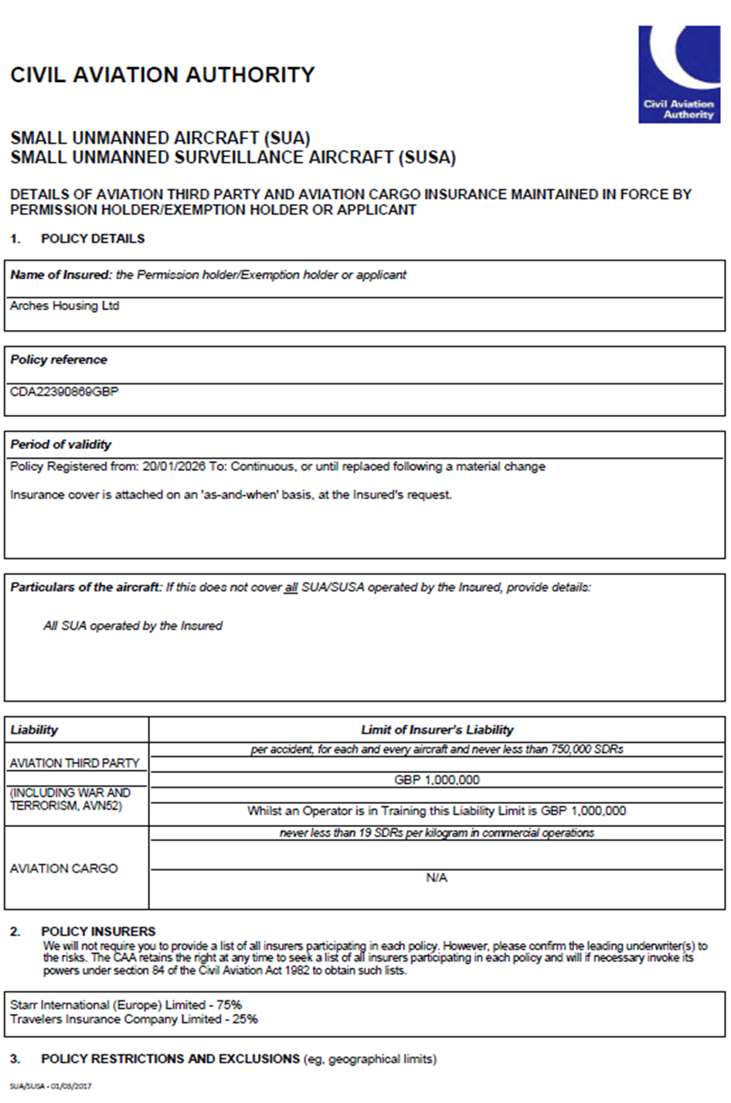
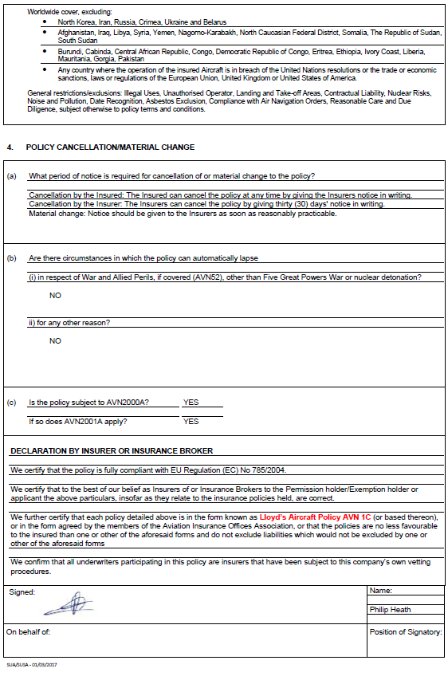

Appendix Q: Data Protection Impact Assessment (DPIA)

All of the below information Must be completed before any flight can commence.
All images are to be stored on SharePoint and are retained as per our data retention policy
ITEM | ACTION/CHECK
Address
Purpose of flight

Data to be captured

Potential Privacy Risks | ☐ High ☐ Medium ☐ Low  Comments:
Mitigation Measures To Protect Data:
Data Retention Period:
Managers Approval | ☐ Yes ☐ No
Managers Signature:/Date

