

double

Social Tenant Access to Information Requirements (STAIRS) Policy

Reference | STAIRS Policy | Version | 1
Staff affected | All staff | Issue date | August 2026
Approved by | Executive Management Team | Review date | August 2029
Lead Officer | Director of Operations | Next review | By August 2029

This policy sets out how Arches Housing will meet the Social Tenant Access to Information Requirements (STAIRS), promote openness and transparency, and support tenants and their representatives to access information about the management of their social housing.
In simple terms: this policy explains what information you can ask Arches Housing for, where you can find information we publish on our website, what we will do when you make a request, and what you can do if you are unhappy with our response.

1. Policy purpose
This policy explains how Arches Housing will provide tenants with access to information it holds, or that is held on its behalf, about the management of social housing. It supports tenants to understand how decisions are made, how services are delivered, how performance is monitored and how Arches Housing can be held to account.
Arches Housing will adopt a presumption in favour of disclosure, unless there is a lawful, reasonable or proportionate basis to withhold or redact information.

2. Policy scope
This policy applies to Arches Housing, its employees, Board members, contractors, agents and third parties acting on its behalf where they hold information relating to the management of Arches Housing’s social housing.
The policy applies to information relating to Arches Housing tenants, homes, neighbourhoods, housing services, governance, decision-making, spending, performance, policies, lists and registers, and other social housing management functions.
It does not replace Arches Housing’s existing obligations under data protection legislation, safeguarding duties, confidentiality requirements, contractual obligations or any other statutory duties.

3. Definitions
Term | Definition
Tenant | A current social housing tenant, licensee or shared owner of Arches Housing who is entitled to access information under STAIRS.
Designated representative | A person authorised to act on behalf of a tenant for the purposes of making a STAIRS request or pursuing a related review or complaint.
Eligible former tenant | A former Arches Housing tenant who made the original STAIRS information request while they were still a tenant.
Held information | Information held by Arches Housing, or held by another organisation on Arches Housing’s behalf, that relates to the management of social housing.
Social housing management | Activities, decisions, services, policies, performance information, records and governance arrangements that relate to how Arches Housing manages its social housing homes and services.
Publication scheme | The information Arches Housing publishes routinely, or makes available in another way, so tenants can find key information without having to make a separate request.
STAIRS request | A request from a tenant or designated representative for relevant information relating to the management of Arches Housing’s social housing.

4. Regulatory framework
STAIRS was introduced through the government’s Social Tenant Access to Information Requirements policy statement. Private registered providers must comply with the Chapter 1 publication scheme requirements from 1 October 2026 and the Chapter 2 information request requirements from 1 April 2027.
STAIRS is reflected in the Transparency, Influence and Accountability Standard regulated by the Regulator of Social Housing and sits alongside the Housing Ombudsman’s role as the complaints body for STAIRS matters.

5. Policy principles
- Transparency: Arches Housing will make relevant information easy to identify, access and understand.
- Accountability: Information will support tenants to scrutinise decisions, performance and service delivery.
- Accessibility: Information will be provided in ways that meet tenants’ communication needs wherever reasonably possible.
- Proportionality: Decisions to withhold or redact information will be reasonable, evidence-based and documented.
- Security: Personal data, confidential information and information that could create harm if disclosed will be protected.

6. Publication scheme
Arches Housing will maintain a publication scheme setting out the classes of information it proactively publishes or otherwise makes available as a matter of routine where the information is held and falls within the STAIRS requirements. The publication scheme will be available through the Arches Housing website and through alternative routes for tenants who cannot access information online.
The scheme will include the seven publication classes set out in the STAIRS policy statement: governance and decision-making; spending; housing stock management; performance; housing services; lists and registers; and social housing management policies and procedures.
Arches Housing will review the publication scheme regularly to ensure information remains accurate, current, relevant and accessible.

7. Information requests
From 1 April 2027, tenants and their designated representatives may request relevant information relating to the management of Arches Housing’s social housing. Requests may be made in writing, by email, through the website, by telephone, in person, or through another accessible route where needed.
Former tenants may also be eligible to pursue a STAIRS matter where the original information request was made while they were still an Arches Housing tenant.
Arches Housing will respond to STAIRS information requests within 30 calendar days of receiving a valid request. If clarification is needed to identify the information requested, the 30-day period will begin when sufficient clarification has been received. If exceptional circumstances mean a response cannot be provided within 30 calendar days, Arches Housing will inform the tenant or representative, explain the reason for the delay, and respond as soon as reasonably practicable.
Requests and responses will be logged for monitoring, assurance and learning purposes.
Records will show how each STAIRS request was received, assessed and answered, including any clarification sought, searches undertaken, disclosure decisions, redactions applied, reasons for withholding information, review outcomes and learning identified.

8. Withholding, redaction, charges and out-of-scope information
Arches Housing may withhold or redact information where it is reasonable to do so, including where disclosure would conflict with data protection law, confidentiality duties, legal privilege, safeguarding obligations, commercial sensitivity, security considerations or statutory restrictions.
Arches Housing is not required to create new information in order to respond to a request or to meet the publication scheme requirements. Where information is already publicly available, Arches Housing may direct the requester to the relevant source.
Where information is withheld or redacted, Arches Housing will explain the reason unless doing so would itself disclose protected information or create a risk of harm.
Arches Housing will not normally charge tenants for information made available under STAIRS. Information published online, inspected by appointment, provided in large print, audio, translated copy or another accessible format will be free of charge for one copy. If additional copies or exceptional formats create a direct cost, Arches Housing may recover only the reasonable actual cost of providing those additional copies and will tell the tenant, designated representative or eligible former tenant in advance.

9. Data protection and personal information
Information that is personal data will be handled in line with UK data protection legislation. Where a request is primarily for the requester’s own personal data, Arches Housing will treat it as a Subject Access Request rather than a STAIRS request.
Arches Housing will take care not to disclose information that identifies another person, reveals personal circumstances, compromises safety, or enables individuals to be identified through combined information.
For further information about how we handle personal data, please see our privacy notice at www.archeshousing.org.uk/about-arches-latest-news/privacy/.

10. Review and complaints
If you are unhappy with how Arches Housing has dealt with STAIRS information, you can ask us to review our decision. This applies if you are a tenant, designated representative or eligible former tenant. You can ask for a review if you think we have failed to publish relevant information, failed to respond properly to your request, missed the required timescale, or withheld or redacted information unreasonably.
You should normally request an internal review within three months of our original response or decision. You can request a review by emailing info@archeshousing.org.uk, calling 0114 228 8100, writing to or visiting our office at 122 Burngreave Road, Sheffield, S3 9DE, or speaking to a member of staff. Internal reviews will be handled as a separate STAIRS review process. They will not be handled through Arches Housing’s standard complaints policy unless the issue is a wider service complaint and falls outside the STAIRS route.
We will aim to complete internal reviews within 30 calendar days. If you remain dissatisfied after our response, or if we do not respond within 30 calendar days, you may refer the matter to the Housing Ombudsman under its separate STAIRS complaints process.
The Housing Ombudsman Scheme allows tenants, and eligible former tenants where the original information request was made while they were still a tenant, to bring a STAIRS complaint within three months of receiving a response from their private registered provider, or within three months of the point at which a response should have been provided. The Ombudsman’s STAIRS complaints process is separate from its existing complaints service and is available at www.housing-ombudsman.org.uk.

11. Roles, responsibilities and assurance
- Board: Provides oversight of compliance with STAIRS and the wider transparency and accountability framework.
- Executive Team: Ensures effective systems, resources and assurance are in place.
- Director of Operations: Oversees operational implementation, customer-facing processes and performance reporting.
- Managers: Ensure teams understand and follow the policy and provide information promptly when required.
- All staff: Identify, preserve and provide relevant information, and seek advice where information may need to be withheld or redacted.
Arches Housing will report periodically to the Executive Management Team and Board on STAIRS implementation and compliance. Reporting will include publication scheme updates, request volumes, response times, clarification requests, redaction and withholding decisions, internal reviews, referrals to the Housing Ombudsman, complaints outcomes, risks and learning actions.

12. Accessibility and communication
Arches Housing will make information available in clear language and, where reasonably possible, in accessible formats. This may include large print, audio, translated copy, Easy Read or another format that helps tenants access the information. Tenants may contact Arches Housing by telephone on 0114 228 8100, by email at info@archeshousing.org.uk, in person at our office at 122 Burngreave Road, Sheffield, S3 9DE, or by speaking to a member of staff.
We will also promote how tenants can access STAIRS information periodically through other tenant communications, including our customer magazine and other appropriate channels and updates.

13. Monitoring and review
This policy will be reviewed at least every three years, or sooner if there are changes to legislation, regulatory standards, Housing Ombudsman requirements, Arches Housing governance arrangements, or operational practice. The publication scheme will be reviewed at least annually.

Annex 1: Publication scheme
The table below sets out the classes of information Arches Housing will routinely publish or make available where the information is held and falls within the STAIRS publication scheme.
STAIRS publication class | Information typically included | Where you can access this information on our website
Governance and decision-making | Senior staff names and roles, organisational structure, governance arrangements, Board and committee information, decision-making processes, policies, tenant consultation information including methodology, tenant meeting minutes and tenant engagement outcomes. | - Our website governance pages.  - Board information pages.  - Policy and publication pages.  - STAIRS publication scheme page.
Spending | Annual report and financial statements, value for money information, procurement information, expenditure on social housing services, service charge information, use of grants and resident-facing financial summaries. | - Annual report and financial statement pages.  - Finance and value for money publications.  - Tenant information pages.  - STAIRS publication scheme page.
Housing stock management | Information about homes, repairs, maintenance, planned investment, building safety, health and safety compliance, damp, mould and condensation, stock condition, net zero and asset management programmes. | - Tenant Hub pages on our website.  - Repairs pages.  - Building safety pages.  - Investment updates.  - Published policies.
Performance | Tenant Satisfaction Measures, complaints performance, service performance, regulatory judgements or notices, inspection outcomes, health and safety performance, eviction information and improvement plans where held. | - How we are doing pages.  - Tenant reports.  - Performance publications.  - Regulatory information pages.  - STAIRS publication scheme page.
Housing services provided | Descriptions of housing services including repairs, rents, service charges, tenancy management, neighbourhood management, anti-social behaviour, complaints, support, advice, getting involved and customer service standards. | - Tenant Hub pages on our website.  - Contact pages.  - Complaints pages.  - Get involved pages.  - Service standard publications.
Lists and registers | Relevant public registers and lists held by Arches Housing that relate to social housing management, including policy registers, governance documents, regulatory registration information and other relevant lists where disclosure is appropriate. | - Arches Housing website.  - STAIRS publication scheme page.  - Relevant public bodies, where applicable.
Social housing management policies and procedures | Policies, procedures and strategies explaining how Arches Housing manages social housing homes, neighbourhoods, tenant services, complaints, repairs, safety, engagement, information governance and related housing management functions. | - Policy and publication pages.  - Tenant Hub pages on our website.  - Customer services information pages.  - STAIRS publication scheme page.

How will relevant information under STAIRS be published?
Information will be available on our website at www.archeshousing.org.uk/tenant-hub/stairs/ and will be regularly updated.
Formats other than online
We are committed to making information listed in our publication scheme available free of charge online. If information is required in an accessible alternative format, we also commit to providing a single copy of this information free of charge.
We will also provide one translated copy of any information you request free of charge.
However, where an individual requests additional copies of information, we may apply charges strictly to cover the actual costs incurred in providing additional copies.
No charge for inspection
Information may be inspected at our offices by appointment free of charge. Please contact us to arrange an appointment.
Tenant feedback on this publication scheme
- Email us at info@archeshousing.org.uk.
- Call us on 0114 228 8100.
- Visit our office at 122 Burngreave Road, Sheffield, S3 9DE.
- Speak to any member of staff in person.

Annex 2
STAIRS Flowcharts
  - Information Request
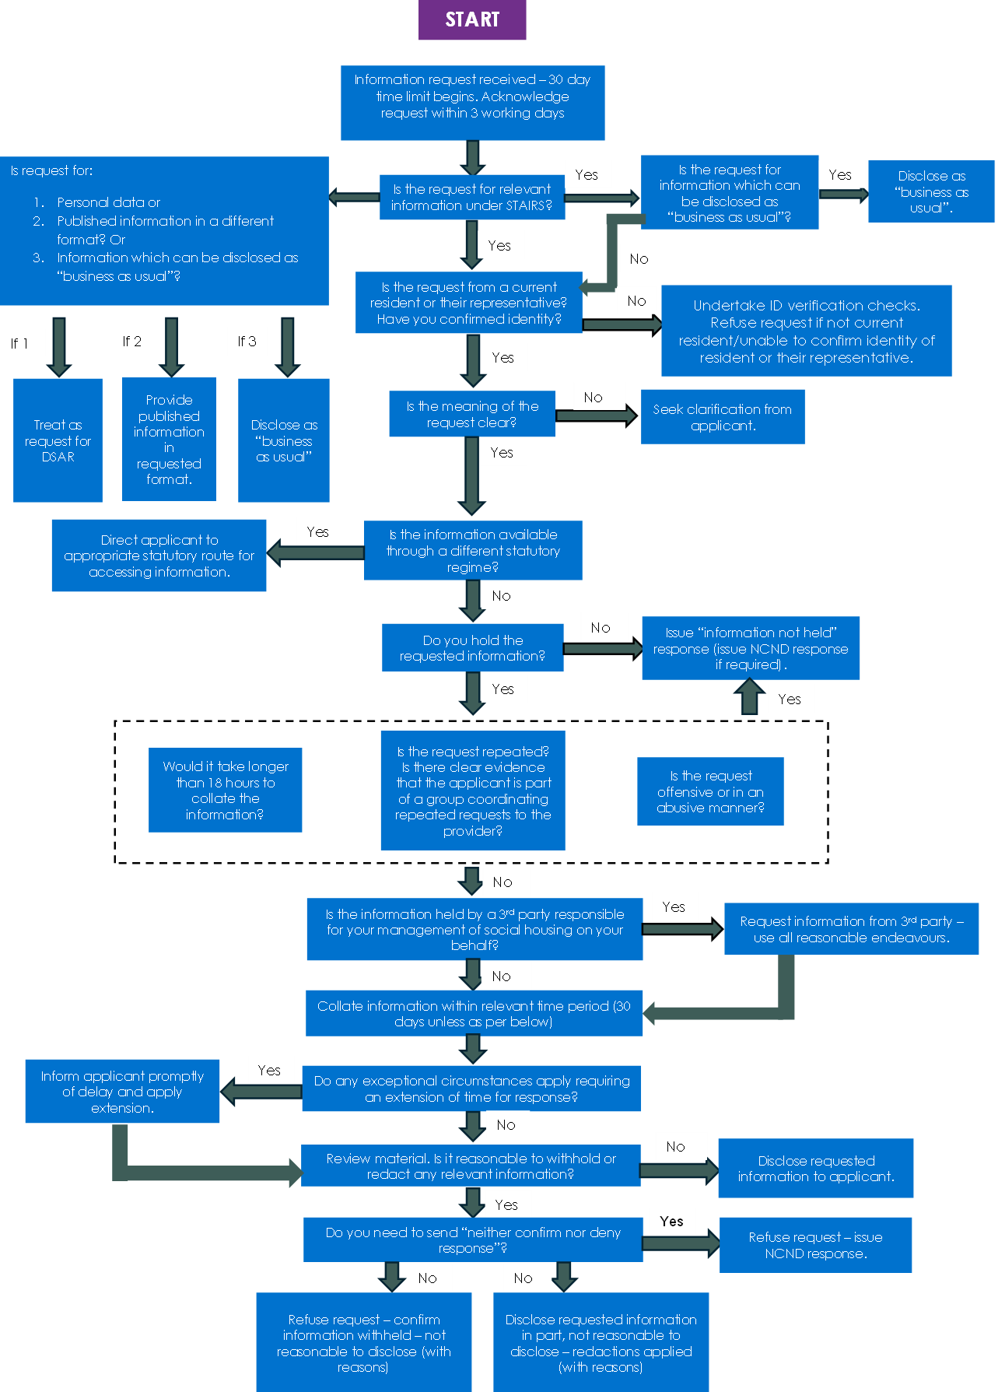

  - STAIRS review process flowchart
